imformation gathering tools :

1.EmailAll

a powerfull eamil collector

Link:

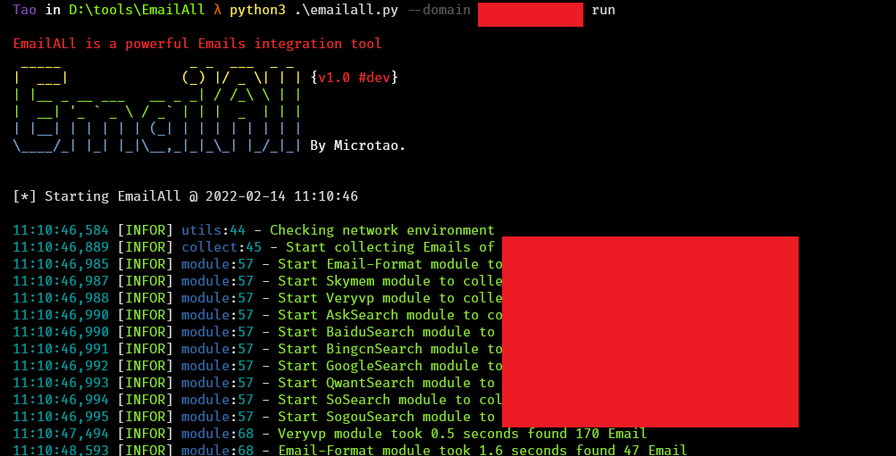https://github.com/Taonn/EmailAll

2.Ip-biter

https://github.com/damianofalcioni/IP-Biter

IP-Biter is an open source, easy to deploy, tracking framework that generate high configurables and uniques tracking images and links to embed in e-mails, sites or chat systems and visualize, in an hacker-friendly dashboard, high detailed reports of the tracked users who visualize the i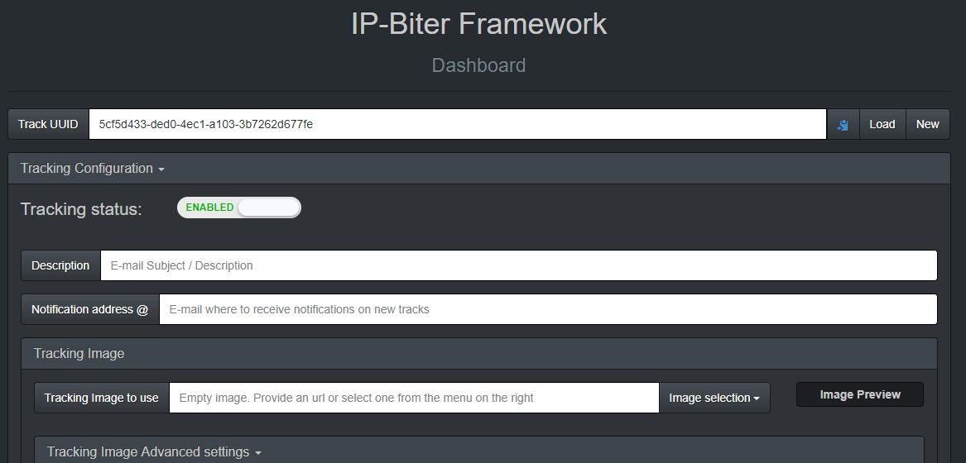mage or open the links.

3.Bane

https://github.com/AlaBouali/bane

this is a python module that contains functions and classes which are used to test the security of web/network applications. it's coded on pure python and it's very intelligent tool ! It can easily detect: XSS (relected/stored), RCE (Remote Code/Command Execution), SSTI, SSRF, CORS Misconfigurations, File Upload, CSRF, Path Traversal,

4.webdork

https://github.com/HACKE-RC/webdork

A Python tool to automate some dorking stuff to find information disclosures.